**Mycophenolate mofetil FDA Label (Last updated 2013)**

**Brand name: CellCept**

Approved on May 3, 1995 for prevention of rejection in kidney transplant patients

Mycophenolate mofetil (MMF) is the prodrug of mycophenolic acid (MPA), which is the active metabolite. MPA is an inosine monophosphate dehydrogenase (IMPDH) inhibitor.

**INDICATIONS AND USAGE**

MMF is indicated for the prophylaxis of organ rejection in patients receiving allogeneic renal, cardiac, or hepatic transplant. MMF should be used concomitantly with cyclosporine and corticosteroids.

MMF IV should be administered within 24 hours following transplantation. IV can be administered for up to 14 days. Patient should be switched to oral as soon as they can tolerate oral medication.

**CONTRAINDICATIONS**

MMF IV is contraindicated in patients who are allergic to TWEEN (polysorbate 80).

**DOSAGES**

Renal transplant (Adults): 1g IV/PO BID

Renal transplant (Pediatrics 3 months-18 years): 600 mg/m2 oral suspension BID

Cardiac transplant (Adults): 1.5g IV BID

Hepatic transplant (Adults): 1g IV BID

**DOSAGE ADJUSTMENTS**

Renal impairment: In renal transplant patients with severe chronic renal impairment (GFR<25) outside the immediate posttransplant period, doses of MMF greater than 1g administered twice a day should be avoided.

Hepatic impairment: No dose adjustments are recommended for renal patients with severe hepatic parenchymal disease. However, it is not known whether dose adjustments are needed for hepatic disease with other etiologies.

**FORMULATIONS**

MMF is available as 250mg capsules, 500 mg tablets, and as a powder for oral suspension, which when constituted contains 200 mg/L of MMF.

Each MMF IV vial contains 500 mg of MMF.

**DDI**

Antacid, PPI, Cholestyramine

Cyclosporine A interferes with MPA enterohepatic recirculation

Sevelamer, Septra, Metronidazole, Ciprofloxacin, Augmentin, Rifampin

**ADVERSE REACTIONS**

The principal adverse reactions associated with the administration of MMF include diarrhea, leukopenia, sepsis, vomiting, infections, pain, anemia, hypertension, and edema.

**SERIOUS SIDE EFFECTS**

Teratogenic

Lymphoma

Infections: Opportunistic, Reactivated Viral Infections (JC virus, CMV, HBV, HCV)

Neutropenia

Pure Red Cell Aplasia (PRCA)

GI Disorders: bleeding, perforations

**CLINICAL PHARMACOLOGY**

Mechanism of Action

MMF has both immunosuppressive and anti-tumor effects. MPA is a potent, selective, uncompetitive, and reversible inhibitor of IMPDH. It inhibits the de novo pathway of guanosine nucleotide synthesis without incorporation into DNA.

Because T and B lymphocyte proliferation are critically dependent on purine synthesis MPA has potent cytostatic effects on lymphocytes. Addition of guanosine or deoxyguanosine reverses the cytostatic effects of MPA on lymphocytes. MPA also suppresses antibody formation by B lymphocytes. MPA prevents the glycosylation of lymphocyte and monocyte glycoproteins that are involved in intercellular adhesion to endothelial cells and may inhibit recruitment of leukocytes into sites of inflammation and graft rejection. MMF did not inhibit early events in the activation of human peripheral blood mononuclear cells, such as the production of interleukin-1 (IL-1) and interleukin-2 (IL-2), but did block the coupling of these events to DNA synthesis and proliferation.

**PHARMACOKINETICS**

Absorption

The mean absolute bioavailability of oral MMF relative to IV MMF (based on MPA AUC) was 94%. The MPA AUC appears to increase in a dose-proportional fashion in renal transplant patients. Food decreases MPA Cmax by 40% but does not affect the extent of absorption (MPA AUC).

Distribution

The mean apparent volume of distribution of MPA is 3.6L in IV, and 4.0L in PO administration. MPA is 97% bound to plasma albumin.

Metabolism

Following oral and IV administration, MMF undergoes rapid and complete metabolism to MPA, the active metabolite. Oral absorption of the drug is rapid and essentially complete. MPA is metabolized by glucuronyl transferase to form the phenolic glucuronide of MPA called MPA-glucuronide (MPAG), which is not active. Then MPAG is converted back to MPA via enterohepatic recirculation.

Due to enterohepatic recirculation, secondary peaks in the plasma MPA concentration-time profile are usually observed 6-12 hours post-dose. Enterohepatic recirculation contributes to MPA plasma concentrations.

Increased plasma concentrations of MPA and MPAG are observed in patients with renal insufficiency.

Excretion

93% of MMF is excreted in urine, 6% excreted in feces. 1% of MPA is excreted in urine. 87% of the administered dose is excreted in the urine as MPAG. MPA and MPAG are not removed by hemodialysis. Bile acid sequestrants such as cholestyramine reduce MPA AUC by interfering with enterohepatic recirculation.

Mean apparent half-life of MPA is 17.9 hours after PO and 16.6 hours after IV administration. Mean plasma clearance of MPA is 193 mL/min after PO and 177 mL/min after IV administration.

**SPECIAL POPULATIONS**

Renal Insufficiency

Plasma MPA AUC observed after oral dosing to patients with severe chronic renal impairment (GFR<25) was about 75% higher relative to that observed in healthy volunteers (GFR>80).

Hepatic Insufficiency

Hepatic MPA glucuronidation processes appeared to be relatively unaffected by hepatic parenchymal disease when PK parameters of healthy volunteers and alcoholic cirrhosis patients within this study were compared. However, it should be noted that for unexplained reasons, the healthy volunteers in this study had about a 50% lower AUC as compared to healthy volunteers in other studies, thus making comparisons between volunteers with alcoholic cirrhosis and healthy volunteers difficult.

Pediatrics

The PK parameters of MPA and MPAG have been evaluated in 55 pediatric patients received oral suspension at a dose of 600 mg/m2 BID after allogeneic renal transplantation. THE PK data for MPA is provided in Table 3.

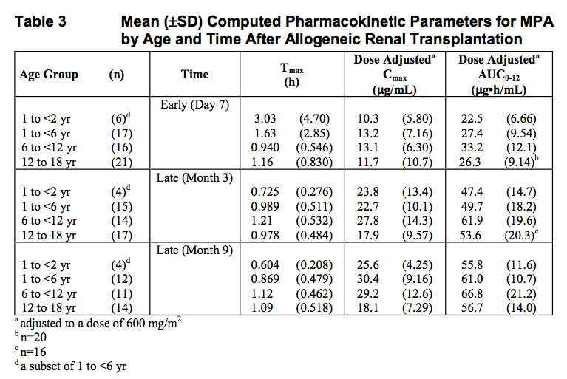

The oral suspension of 600 mg/m2 BID achieved mean MPA AUC values in pediatric patients similar to those seen in adult renal transplant patients receiving capsules at a dose of 1g BID in the early posttransplant period. As observed in adults, early posttransplant MPA AUC values were approximately 45% to 53% lower than those observed in the later posttransplant period (>3 months).

**CLINICAL STUDIES**

Adults

The safety and efficacy of MMF in combination with corticosteroids and cyclosporine for the prevention of organ rejection were assessed in 3 renal, 1 cardiac, and 1 hepatic trials (for specifics, please see page 10 of package insert).

Pediatrics

One open-label, safety and PK study of oral suspension 600 mg/m2 BID in combination with cyclosporine and corticosteroids was performed in 100 pediatric patients (3 months to 18 years of age) for the prevention of renal allograft rejection. The PK profile was similar to that seen in adult patients dosed with 1g BID capsules.